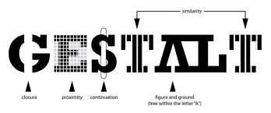

A topic that I am thoroughly interested in that I wanted a more in-depth study of is the Gestalt Principles. As we have learned in previous classes were the methods and theories that are meant to guide our design flow by a series of principles. The Gestalt Principles attempt to organize the specific principles into “unified wholes.” The names of the principles are: Similarity, Continuation, Closure, Proximity, Figure and Ground. Starting with my first design class back in 2005 and all the way through the few schools I’ve attended, the values based on the Gestalt Principles have been impressed upon me. Therefore, I can see how important and universal they are I would really love to embed them into my brain. I really don’t think they are confusing but actually quite the opposite however I have not really studied them to the point where I’m considering them when flowing through a design. Step one would be to become familiar with the principle names themselves, enough where I can recite them verbatim while working on a project. Once you have memorized the names, you have their basic gist and you can begin to visualize the properties of the principle when the name comes to mind.

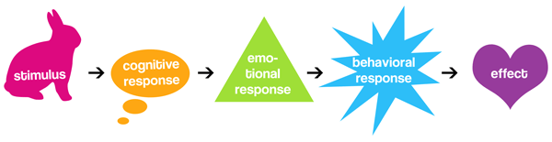

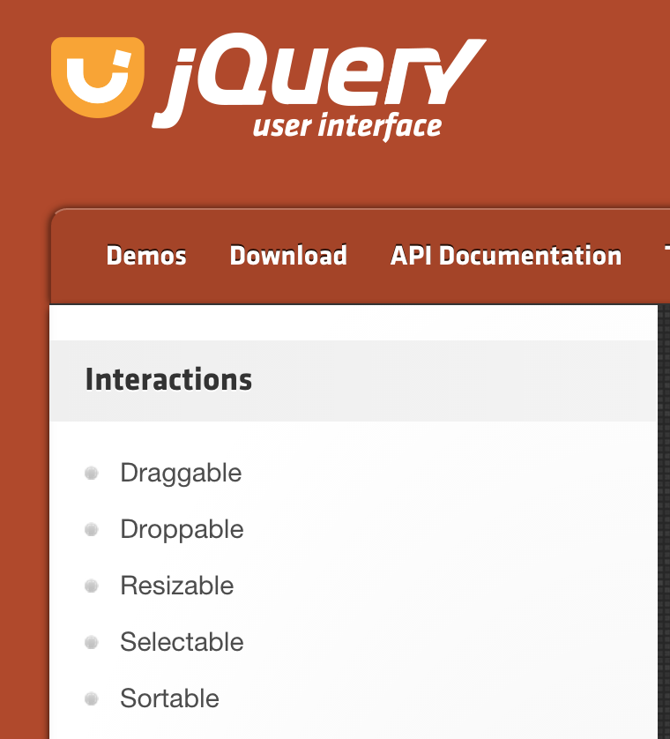 What I found out is that the Gestalt Principles is a proposed theory based on studied cognitive behaviors. I knew that existed for a purpose based on where the eyes seem to flow while browsing through a design but it goes deeper than that. Using a method based on how users consciously and sub-consciously perceive my design will create an extremely functional product. Also, I re-discovered the principles themselves and their terms and I wanted to go over them. Similarity means just like it sounds, making elements similar will cause the viewer to see similar elements in a separate group from another set of similar elements. For web design, an example of similarity would be a nav-bar styled the same or a set of links styled the same to group them together for the user to clearly follow and navigate. The JQuery UI page uses similarity to group nav links. As you can see the main nav and the side nav look like entirely different groups because of how they’re styled. The links similar in design look they are related and therefore achieving the “unified whole” we’re aiming for.

The next principle is Proximity, which is groups off items that are in close proximity, aka placed close together. As you can see from the bare minimum design that is Craigslist, there is still a sense of organization with the use of Proximity. Here is an example and are you can see, the items in a group are close together so that you can tell that they’re part of the same group.

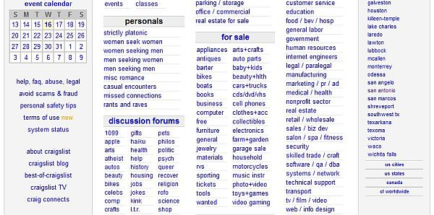

Continuation is the next Gestalt Principle, which groups items based on their continuity, or when they’re in some type of continuous flow or progression. In web design, I think the lightbox feature performed via JQuery is a great example of continuity because of its perpetual nature. You can continually keep going through the photos as they cycle through infinitely and they are clearly contained in the lighbox frame design.

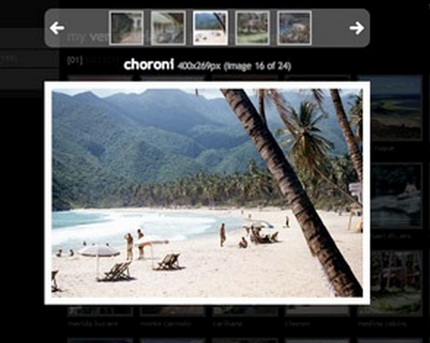

Closure is another Gestalt Principle, which occurs when there is a group where the space is not completely enclosed, however the user is able to distinctly perceive the missing information from the space. This principle relies heavily on the influence of negative space. The WWF logo demonstrates this principle well. As you can see from studying it, your eyes fill in the rest of the Panda bear.



The final principle is Figure and Ground, which is based upon the relationship between an object and its background and making them look as one separate grouping. This can be done through styling, imagery, and much more in web design. The illusion where there is a mans face who’s outline also can be viewed as a vase when studying the negative space. The painter Alex Grey does this well in many of his painting like the one shown below:



I thoroughly enjoyed this review of the Gestalt Principles as I know have them fresh in my mind and will consider them when going through this course and future projects.